Texas Geography Portfolio Book

Note: All maps must be labeled and colored. Follow directions carefully. Neatness counts!

1. Cover (10 points)
Design a cover on the Texas shape and cut out. The cover design should have Texas related material on it. The map should also be colored.

2. Rivers (20 points)
Label the 12 rivers on the Texas River Map (page 39 & A7 in textbook). Trace over all rivers with a dark colored blue map pencil. Color the rest of the state any light color you choose except blue.

3. Cities (20 points)
Label the following cities on the Texas Cities Map (pages 46, 52, 55, 58 in textbook). Cities:

Abilene, Amarillo, Austin, Brownwood, Bryan-College Station, Brownsville, Corpus Christi,
Dallas, Del Rio, El Paso, Ft. Worth, Houston, Laredo, Lubbock, Midland, Mineral Wells, Nacogdoches, San Angelo, San Antonio, Texarkana, Tyler, Wichita Falls. Place a dot where the city is located on the map then write the name of the city beside the dot (the capital of Texas should be labeled with a star instead of a dot). Color the rest of the state any lighter color you choose.

4. Regions (15 points)
Label and color the four major regions on the Texas Regions Map (page 43 in textbook). Each region must be colored a different color.

5. Landforms & Highways (20 points) Draw and label the following landforms and highways in Texas (pages A7, 46, 55, 58 in textbook and overhead): Guadalupe Peak, Davis Mountains, Chisos Mountains, Big Bend National Park, Llano Estacado, Edwards Plateau, Balcones Escarpment, Piney Woods, Interstate 10,
Interstate 20, Interstate 35, and Interstate 45. Color the rest of the state any lighter color you choose.

6. Questions (15 points)
Answer questions on the map. Number your answers on the map to correspond with the question being answered. Answers must be in complete sentences.

7. Arrange the maps in order from the numbers above (1-6) and staple in the upper left corner. Put your name, date, and class period on the back of the last map.

Do NOT cut out maps until all maps are finished
& you are ready to turn in!

Cover: 10 points
Design a cover on the Texas shape and cut out map. The cover design should have Texas related material on it. The map should also be colored. Neatness is a big part of the grade for the cover.

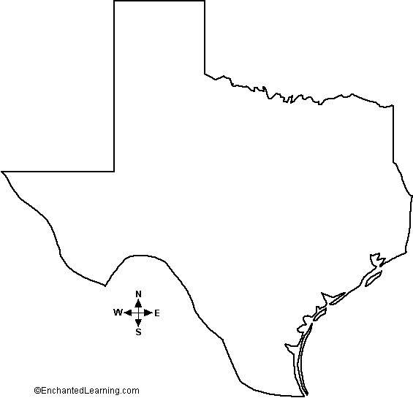

Rivers: 24 points
Label the 12 rivers on the Texas River Map (page 39 & A7 in textbook). Trace over all rivers with a dark colored blue map pencil. Color the rest of the state any light color you choose except blue. Cut out map. Neatness is part of the grade.

(Pre-AP): Why do you think rivers were so important to the people and the settling of Texas? Answer on the back of your COVER.

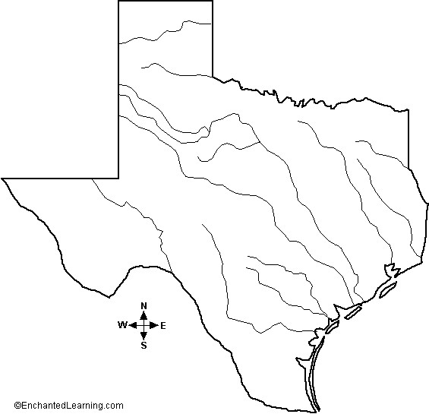

Cities: 26 points
Label the following cities on the Texas Cities Map (pages 46, 52, 55, 58 in textbook). Cities: Abilene, Amarillo,

Austin, Brownwood, Bryan-College Station, Brownsville, Corpus Christi, Dallas, Del Rio, El Paso, Ft. Worth,
Houston, Laredo, Lubbock, Midland, Mineral Wells, Nacogdoches, San Angelo, San Antonio, Texarkana, Tyler, Wichita Falls. Place a dot where the city is located & write the name of the city beside the dot (the capital of Texas should be labeled with a star). Color the rest of the state any lighter color you choose.

(Pre-AP): Which city on the map have you visited? Pick 3 words that you would use to describe the city and explain why you chose those words in one 3-5 sentence paragraph. Answer on the back of your RIVERS page.

Regions: 18 points
Label and color the four major regions on the Texas Regions Map (page 43 in textbook). Each region must be colored a different color. Cut out map. Neatness is part of the grade.

(Pre-AP): Choose one of the 4 major Texas region (or a sub-region if you want). Imagine you live there, wake up one morning and walk out onto your front porch. Describe what you see. Write a minimum of
3-5 articulate, descriptive sentences depicting what’s in your vision. Answer on the back of your CITIES page.

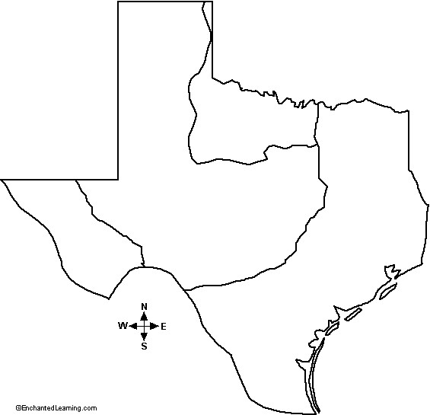

Landforms & Highways: 20 points
Draw and label the following landforms and highways in Texas (pages A7, 46, 55, 58 in textbook and overhead): Guadalupe Peak, Davis Mountains, Chisos Mountains, Big Bend National Park, Llano Estacado, Edwards Plateau, Balcones Escarpment, Piney Woods, Interstate 10, Interstate 20, Interstate 35, and Interstate 45.

(Pre-AP): What do you notice about the numbering of the interstates? Which city on the map have you visited? Pick 3 words that would describe the city and explain why you chose those words in a 10 word summary. Answer both questions on the back of your RIVERS page.

Questions: 15 points
Answer the following questions on the map below. Number your answers on the map to correspond with the question being answered. Answers must be in complete sentences. Neatness counts!
- Compare your cities map to your rivers map. From your comparison, where are most cities located? Speculate why settlers would choose to build cities at these locations?
- Examining your maps and notes, what can you infer about the geography of Texas? (Hint-examine the geographic features and climate of all four regions) Be detailed in your explanation.
- Speculate how the climate and physical features have influenced the population of Texas? You must discuss which area has a higher population & why and which area has a lower population and why.

